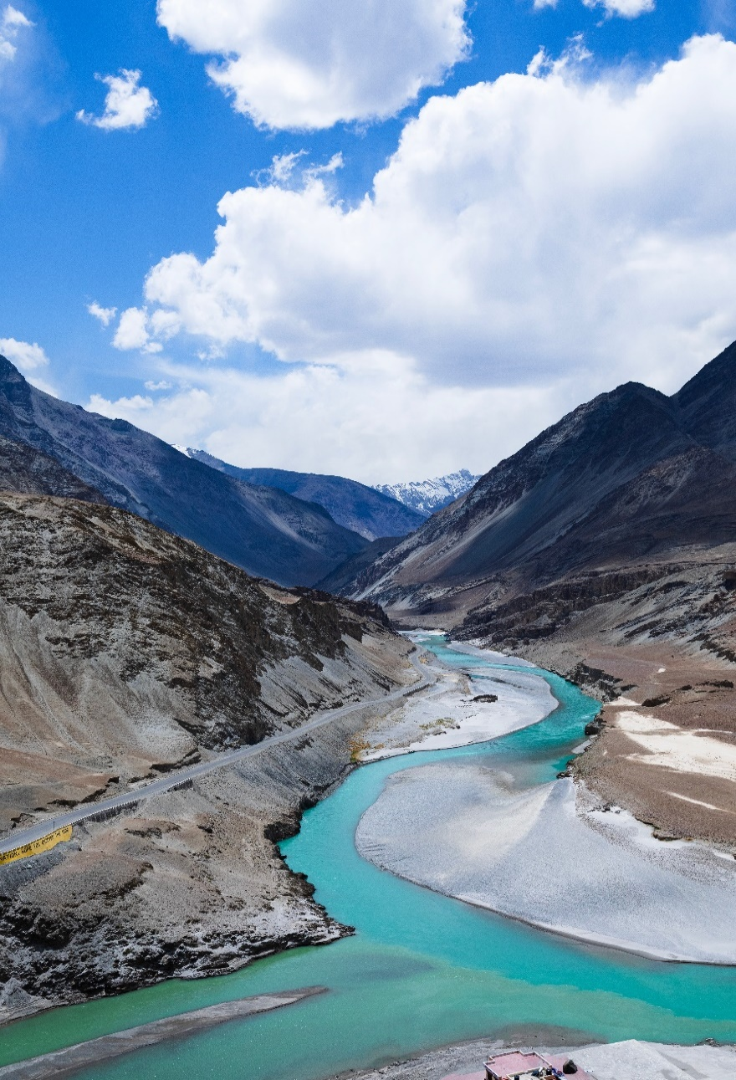

Seasonal snow cover evolution in Ladakh since 2000.

**Dr. Mohd Farooq Azam**

Associate Professor & INSPIRE Faculty Fellow | Discipline of Civil Engineering

Indian Institute of Technology Indore

Nachiket Salunke | Naman Agrawal | Namonarayan Meena

# Abstract

The northernmost area of India, Ladakh, is known for its harsh and cold climate, with seasonal snow cover playing a crucial role in its hydrological cycle. In this study, we use remote sensing data from the MODIS (or Moderate Resolution Imaging Spectroradiometer) to assess the seasonal snow cover evolution in the Ladakh region since 2000. We observed a notable reduction in the duration and amount of snow cover throughout the winter months, which has substantial ramifications for the region's management of water resources, agriculture, and tourism. The study indicated how important it is to better understand and manage the snow cover in the Ladakh region, especially considering the evolving global climatic conditions.

**Keywords:** Snow cover, Ladakh, MODIS, accumulation, ablation, snow cover variation

# Introduction

Ladakh only receives snowfall in the winter, however the snow cover is an essential part of the region's hydrological cycle since it supplies water for drinking and cultivation. Unfortunately, the dynamics of the snow cover in the Ladakh region are being significantly impacted by climate change, with decreased snow cover duration and extent being noted in recent years. This is concerning because the area already struggles with water shortages and depends significantly on snowmelt for cultivation and drinking water.

In this study, we use remote sensing data to study the seasonal snow cover evolution in the Ladakh region since 2000. Particularly, we will use MODIS A2 satellite data to examine the seasonal variations in snow cover amount, duration, and timing of snowmelt. We will also examine how managing water resources, agriculture, and tourism may be affected by the decreasing snow cover. This study is significant because it will offer essential insights into the dynamics of the altering snow cover in the Ladakh region, which can inform adaptive management plans and policies meant to ensure the region's residents have access to both food and water. Also, the project will advance knowledge of the patterns of snow cover in high-altitude locations and their vulnerability to climate change.

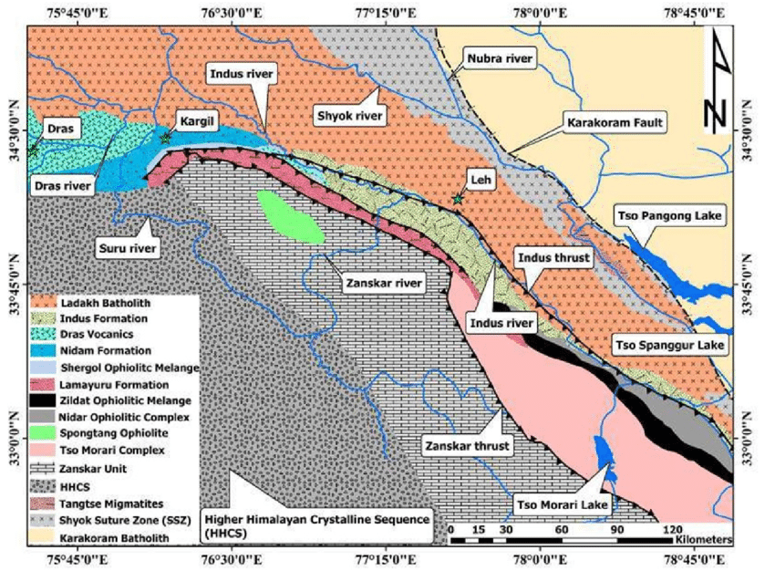

Figure 1 | Geological map of Ladakh Himalaya

# Literature Review

The seasonal snow cover in the Ladakh region has been the subject of numerous investigations in the past. In research published in 2012, Singh et al. used remote sensing data to examine how the snow cover changed between 2000 and 2010. The duration and area of the snow cover in the territory decreased, which they linked to the warming temperatures and changing precipitation patterns. Using remote sensing data from 2000 to 2012, Kumar et al. (2014) conducted another study to examine the patterns of snow cover decrease in the Ladakh region. Rangwala et al. (2012) examined trends in the western Himalayan snow cover from 2001 to 2012. The study established a relationship between elevation, precipitation, and snow cover.

# Methodology and Data Sets

The MODIS snow cover product used for the study has been available from the National Snow and Ice Data Centre of the United States (NSIDC) since March 2000. The Normalized Difference Snow Index (NDSI) is used to differentiate snow and non-snow areas based on reflectivity in visible and near-infrared ranges in MODIS’ snow mapping algorithm. Level 3 eight-day snow cover data (MOD10A2) provides the snow data in eight days interval with a spatial resolution of 500m. MOD10A2 is a composite of MOD10A1 data collected for 8 days and compiled such that the product has maximum snow cover and minimal cloud cover. According to several studies, it has been found that MODIS eight-day maximum snow cover products and ground observation are in reasonable agreement. MOD10A2 has lower cloud coverage in the data as compared to MOD10A1. According to the manual provided by NSIDC, there are different pixel values representing distinct ground objects. 0 represents missing data, 1 represent no decision, 11 represents night, 20 represents no snow, 37 represents lake, 50 represents clouds, 100 represents lake ice and 200 represents snow. If a snow cover is detected on any of the 8 days, the pixel will be labelled as snow; however, if cloud is on all 8 days, the pixel will have cloud cover value. So, the MOD10A2 provides highly reliable data that is being used to accurately investigate the spatial and temporal variation of snow cover over the Himalayan region.

For this study, a total of 6 years of MOD10A2 data is collected starting from February 26,2000 followed by 2005, 2010, 2015, 2015 and 2022. While downloading the data, the sinusoidal projection of MOD10A2 datasets were converted into Universal Transverse Mercator (UTM) projection on the World Geodetic System (WGS84). If the cloud cover for a specific day >15%, the linear interpolation is used to obtain the snow cover of that day.

To obtain the snow-covered areas of Ladakh, QGIS is used. Firstly, the shape file of Ladakh and the raster layers (in GeoTiff file format) is added and Ladakh region is extracted from the raster layers. The pixel having value 200 is obtained from the clipped file and the rest are discarded using raster calculator. Using raster analysis, the pixel count for pixel value 200 is obtained and hence the area is obtained by using the pixel area.

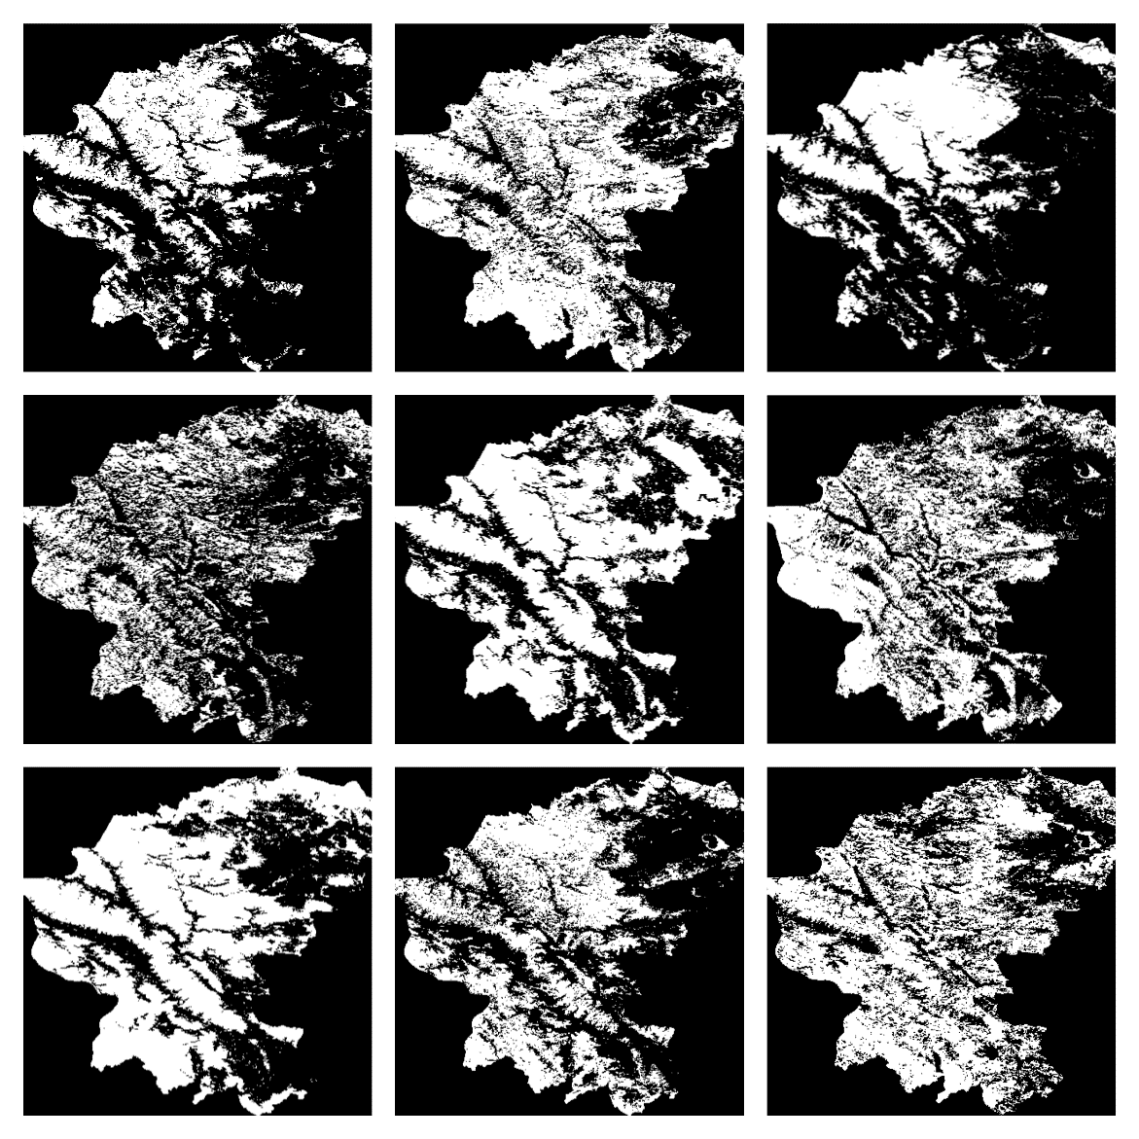

Figure 2 | Processed data from MOD10A2 in QGIS

# Results and Discussion

The distribution of snow cover in certain areas of the region show significant heterogeneity in terms of the spatio-temporal variations. The percentage snow cover area has been estimated as the ratio of the areas of pixels recognized as snow and the total number of pixels for the region. A year in the area has four different seasons: winter (November-February), spring (March-May), summer (June-August), and fall (September-October). These four seasons can be separated into accumulation (September-March) and ablation (April-August). For simplicity in explaining and understanding, we may refer to the periods of accumulation and ablation as the winters and summers respectively.

The pattern of precipitation observed in the region does not conform to the traditional pattern observed all over the country. This can be explained by the various characteristics and factors that influence and define the region.

1. Altitude: Ladakh is located at an extremely high altitude; most of the territory is above 3,000 meters.
2. Topography: The topography of the area, which features steep mountains and deep valleys, significantly affects snowfall patterns. Snowfall can result from moist air rising due to mountains, whereas valleys can trap cold air and prevent it from escaping, resulting in lower temperatures and greater snowfall.
3. Latitude: Because Ladakh is located at a high latitude, it experiences lower temperatures and less direct sunlight, which might lead to greater snowfall.
4. Monsoon winds: Snowfall in Ladakh may be affected by the monsoon winds that blow across India. The monsoon winds bring moisture to the area in the summer, which can cause significant snowfall in the winter.
5. Landlocked: Ladakh is far from any seas or significant bodies of water because it is in a landlocked area. It thus has a continental climate, defined by low humidity and dry air. Less snow may fall in these areas than in those near to the ocean due to the dry air.

Overall, a variety of meteorological and atmospheric variables influence the geological processes that govern snowfall in Ladakh, making them complicated and linked.

1. (B)

1. (D)

(E) (F)

Figure 3 | Snow Cover Variation (%) vs Days, (A) Year 2000, (B) Year 2005, (C) Year 2010, (D) Year 2015, (E) Year 2020, (F) Year 2022

The data analysis revealed a very clear seasonal variation in the snow cover area in the region. The snow cover area peaked around the month of March with the maximum snow cover reaching around 46% of the total area of the region. From then on, the snow starts to melt, with a substantial amount melting away, leaving as low as around 11% of the region covered in snow during the ablation months, only tall mountains and glaciers are found to retain the snow. This further decreased to around 8-9% in the second decade of the century. Snowfall resumes in September, increasing steadily until a sharp spike in March. The seasonal accumulation of snow showed an increase from the year 2000 to 2005 and from then on has followed a decreasing trend till the year 2022. Maximum snowfall and rainfall rates during the spring corresponding to our findings are attributed to the maximum snow cover during the beginning of spring. The ablation occurs more gradually than the local snowfall. The average annual snow cover fluctuates between 19.60% to 27.65% during the research period. The average snow cover for the complete period of research is 24.52% of the total area.

Observational data show a significant warming during the winter season which matches with the findings from our study. The snow-covered area over the region shows decline over the last two decades between years 2000 and 2022. The annual average snow cover area in the region showed an increasing tendency from 2000 to 2005 then followed a decreasing trend both in ablation season (April-August) **(Figure 4A)** and accumulation season (September-March) **(Figure 4B)**, with summer being more distinctive than winter. The year 2015 experienced the highest extent of snow cover, covering around 27.65% of the region. The lowest amount of snow cover ever observed was around 19.60% in the year 2000 (data for the year was only available February 2000 onwards).

(A)

(B)

Figure 4 | Monthly Snow Cover Variation (%) from 2000 to 2022 for (A) Ablation Season and (B) Accumulation Season

A recurring pattern of stable snow cover over the course of the season during the summer months was observed. The snow cover area did, however, vary significantly throughout the winter. The overall trend study indicated that during the winters, snow cover area will remain stable or show a slight increase. The area covered by snow has decreased for the months of March and June in comparison to the previous decades. The monthly variations in the snow cover areas over the years during summer and winter are depicted in **Figures 4 (A), (B)** respectively. A further comparison in the snow cover variation over the years has been depicted in **Figure 5**.

Figure 5 | Comparison of Snow Cover Variation (%) vs Days over the years

# Conclusion

# We assessed the characteristics and variations of snow cover area in the Ladakh region between 2000 and 2012 using the MODIS MOD10A2 data.

# Despite the widespread perception that snow cover area is decreasing in mountainous areas as a result of global warming, we found little to no change in the growing trend in the variation of snow cover area in the Ladakh region. We do not assert that the valley is more resistant to climate change because the time period of research was limited to 20 years, which is insufficient to detect any clear trend. The key points from the study can be listed as:

1. The area covered by snow on an average annually is around 24.52%.
2. The average extent of area covered by snow annually was highest in 2015 (27.65%) and lowest in 2000 (19.60%).
3. Similarly, the monthly average was highest for the month of March (35.16%) and lowest in August (11.20%).
4. Snowfall in the region starts in the month of September and ends in April.

# References

Singh, D., Sharma, V., and Juyal, V. (2015). Observed linear trend in few surface

weather elements over the northwest Himalayas (NWH) during winter season’. J. Earth Syst. Sci. 124, 553–565. doi: 10.1007/s12040-015-0560-2.

Kumar, Jatinder & Rai, Himanshu & Khare, Roshni & Upret, D. & Dhar, Priyanka &

Tayade, Amol & Chaurasia, Om & Srivastav, R. (2014). Elevational controls of

lichen communities in Zanskar valley, Ladakh, a Trans Himalayan cold desert. *Tropical Plant Research*. 1. 48-54.

Jain, S.K., Lohani, A.K., Singh, R.D. et al. Glacial lakes and glacial lake outburst

flood in a Himalayan basin using remote sensing and GIS. *Nat Hazards* 62, 887–

899 (2012). <https://doi.org/10.1007/s11069-012-0120-x>.

Pandey, A., et al. (2016). Analysis of snow cover dynamics and its relation with

glacier mass balance in Leh and Zanskar range, northwest Himalaya. *Journal of Earth System Science*, 125(3), 471-485.

Sharma, S., et al. (2019). Spatio-temporal variations of snow cover duration over the

western Himalayan region using MODIS data (2000–2017). *Theoretical and*

*Applied Climatology*, 138(1-2), 53-69.

Rangwala, Imtiaz & Miller, James. (2012). Climate change in mountains: a review of

elevation-dependent warming and its possible causes. *Climatic Change*. 114.

10.1007/s10584-012-0419-3.